DataForge Infrastructure Notes

1.Introduction
This document defines the infrastructure requirements for setting up and running the DataForge platform in a local development environment. It provides information about the required software components, supported operating systems, hardware specifications, and environment setup procedures. The purpose of this document is to ensure that all team members can reproduce a consistent and reliable development environment.

2.Infrastructure Scope
The DataForge prototype is designed as a local development environment that demonstrates the core functionality of the platform. The system focuses on data ingestion, event streaming, processing, and storage using open-source technologies. All components are deployed on a single machine to simplify setup and ensure reproducibility for all team members.
The prototype consists of PostgreSQL, Apache Kafka, Apache Spark (PySpark), Docker Desktop, and Python. Together, these technologies create a complete end-to-end data pipeline capable of simulating real-time data processing workflows.

2.1.Prototype Environment Overview
The DataForge prototype is a simplified version of the intended production environment. It demonstrates data ingestion, event streaming, processing, and storage on a single development machine. The following figure provides an overview of the prototype architecture and its main technologies.
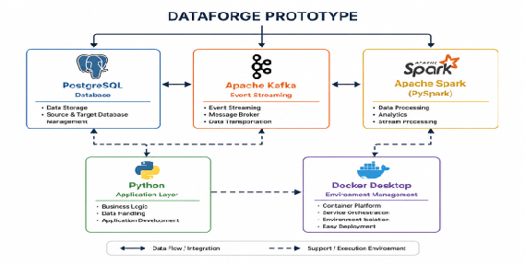
The prototype environment integrates PostgreSQL, Apache Kafka, Apache Spark (PySpark), Python, and Docker Desktop into a single platform. Together, these technologies provide the core infrastructure required for data storage, streaming, processing, and application execution.

2.2.Prototype Characteristics and Performance Targets
The DataForge prototype is intended to demonstrate the feasibility of the proposed data pipeline architecture rather than achieve full industrial-scale performance. As a result, several performance targets and operational characteristics have been adjusted to match the constraints of a local development environment.
Compared to an industrial deployment, the prototype uses simplified infrastructure, simulated data sources, and a single-machine setup. While this reduces overall throughput and scalability, it provides a practical platform for development, testing, and demonstration purposes.
The following diagram compares selected industrial performance targets with the corresponding prototype objectives.
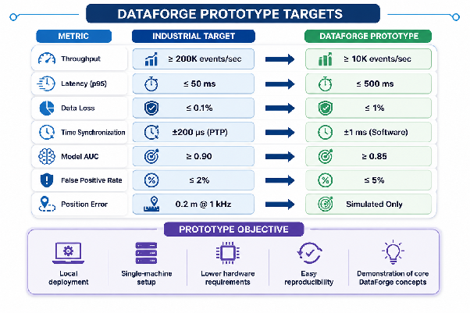
The figure compares the performance expectations of an industrial-scale environment with the objectives of the DataForge prototype. While the prototype does not aim to achieve enterprise-level performance, it provides sufficient capabilities to demonstrate the core concepts of data ingestion, event streaming, processing, and storage. The simplified architecture also enables easier deployment, reproducibility, and development within a local environment.

2.3.Contribution of Prototype Architecture
While the previous sections introduced the technologies used in the DataForge prototype and the performance objectives of the system, it is also important to understand how each component contributes to achieving these objectives. Each technology plays a specific role in supporting reliability, performance, scalability, maintainability, and efficient data processing within the prototype environment. The following diagram illustrates the relationship between the DataForge components and the prototype targets they help achieve.
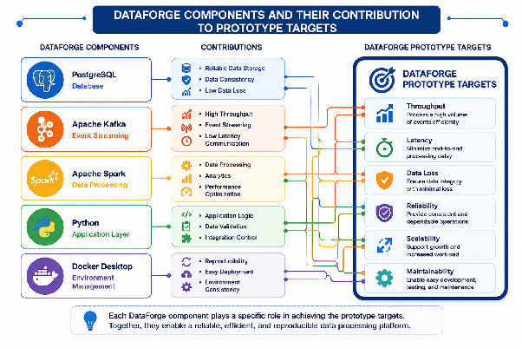
As shown in the diagram, each component contributes to different aspects of the DataForge prototype. PostgreSQL provides reliable data storage, Apache Kafka enables event streaming, Apache Spark supports data processing, Python handles application logic, and Docker ensures deployment consistency. Together, these technologies create a reproducible and efficient prototype environment that supports the project's performance and reliability objectives.

3.Hardware and Software Requirements

3.1.Overview
The DataForge prototype combines multiple technologies that work together to support data storage, event streaming, processing, and application development. To ensure stable operation of all components, the development environment must satisfy a set of hardware and software requirements. These requirements are intentionally designed for a local prototype environment and are significantly lower than those of a production-scale deployment.
The infrastructure requirements of the DataForge prototype can be grouped into three main categories: operating system requirements, software requirements, and hardware requirements. The following diagram provides an overview of these requirements and the technologies needed to support the prototype environment.
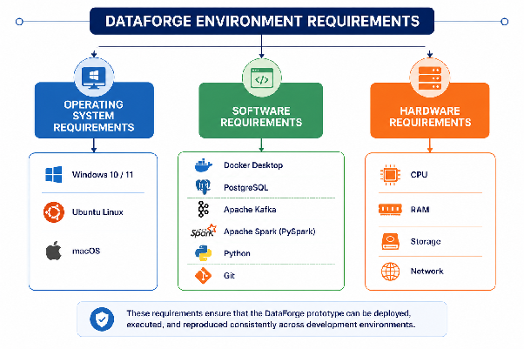
The requirements shown above define the foundation of the DataForge development environment and ensure that all prototype components can operate together effectively and consistently.

3.2.Operating System Requirements
The DataForge prototype is designed to be platform-independent and can be deployed on multiple operating systems. Since all major components used in the prototype provide cross-platform support, team members can develop and test the system using Windows, Linux, or macOS environments.
The supported operating systems for the DataForge prototype are summarized in the following diagram. The comparison highlights platform compatibility and provides recommendations for selecting the most suitable development environment.
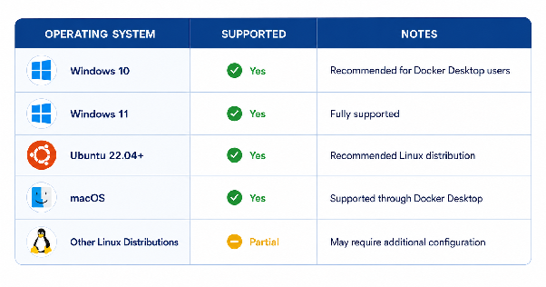
As shown in the diagram, Windows 10/11, Ubuntu 22.04+, and macOS are fully supported environments for the DataForge prototype. Other Linux distributions may also be used, although additional configuration steps may be required.

3.3.Software Requirements {#3.3.software-requirements}
The DataForge prototype relies on several software components that provide data storage, event streaming, data processing, containerization, and version control capabilities. These tools form the core technology stack of the prototype and must be installed before development can begin.
The software components required for the DataForge prototype are presented in the following diagram.
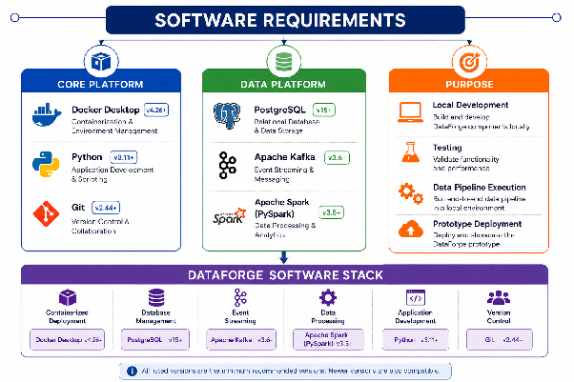
The diagram illustrates the software stack required for the DataForge prototype and the role of each component within the system architecture. Together, these technologies provide the capabilities needed for data storage, event streaming, data processing, application development, and version control.
The listed versions represent the minimum recommended requirements for stable operation. By combining these components, the DataForge prototype can be deployed, tested, and maintained within a reproducible local development environment.

3.4.Hardware Requirements
Although the DataForge prototype is designed as a lightweight local environment, sufficient hardware resources are required to run multiple services simultaneously. PostgreSQL, Apache Kafka, Apache Spark, Docker Desktop, and Python applications consume CPU, memory, and storage resources during development and testing activities. The following requirements ensure stable operation of the complete prototype environment.
The recommended hardware requirements for the DataForge prototype are presented in the following diagram.
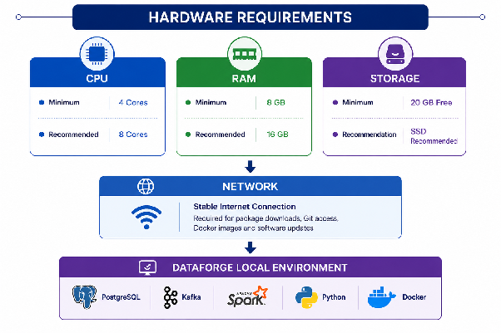
The hardware requirements presented above represent the minimum and recommended specifications for running the DataForge prototype in a local development environment. These resources are sufficient to support PostgreSQL, Apache Kafka, Apache Spark, Python, and Docker Desktop simultaneously while maintaining stable system performance during development and testing activities.

4.Conclusion
The DataForge prototype demonstrates how modern data engineering technologies can be combined to build a complete end-to-end data pipeline in a local development environment. By integrating PostgreSQL, Apache Kafka, Apache Spark, Python, and Docker Desktop, the prototype supports data storage, event streaming, data processing, and application development within a single reproducible platform.
The infrastructure requirements presented in this document provide a practical foundation for deploying and testing the prototype on commonly available hardware and operating systems. Compared to a production-scale environment, the prototype reduces complexity while still demonstrating the core concepts and workflows of the DataForge platform.
Overall, the proposed environment enables efficient development, testing, and validation of DataForge components and serves as a solid basis for future expansion toward larger-scale deployments.

